- Go to www.busythings.co.uk
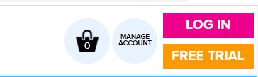
- Click log in

- Username: home6957 password: monster5632 (no space between words or numbers)

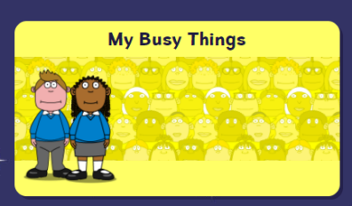
- Click ‘My Busy things’ below.

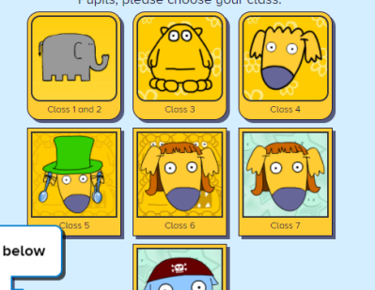

- Then click ‘Class 1 and 2’.

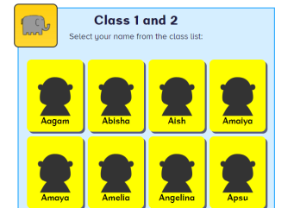

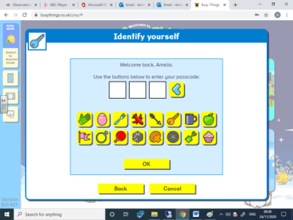
- Find your child – you will have to scroll down as it goes in alphabetical order.

- Then type in their passcode.

- Then you should see all the activities set.

- There are three activities that have been assigned and they will appear on the 21.02.22: They are
- Alphabet ordering
- Ordering the days of the week and
- Designing a pancake as we will talk about this celebration when the children return after half-term.
Your child’s busy things log in is in the back of their reading record.

